Eg: Remove_Duplicates_From_2Files_To_Form_Unique_Elements_InResult

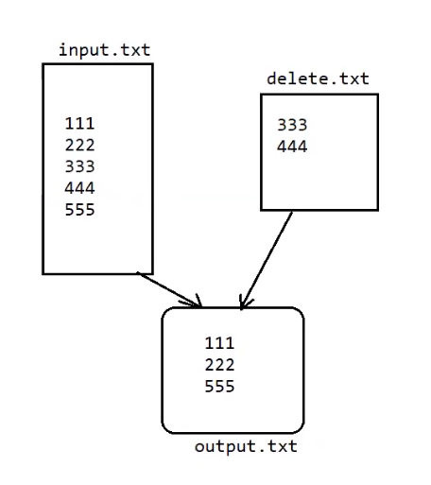

Eg: Highest_No_Of_Characters_String_In_File

// go through the code

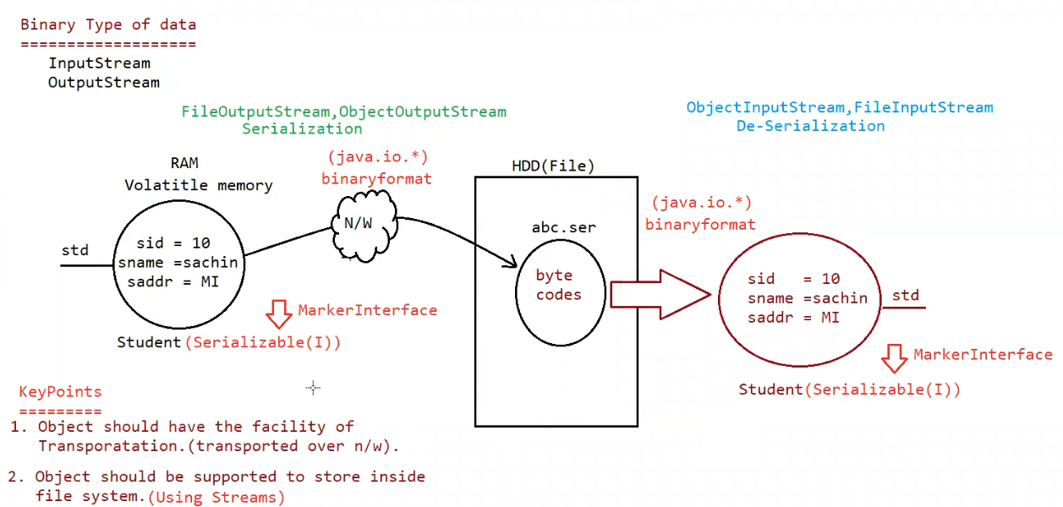

Serialization:

The process of saving (or) writing state of an object to a file is called serialization but strictly speaking it is the process of converting object from java supported form to wither network supported form (or) file supported form

By using FileOutputStream and ObjectOutputStream classes we can achieve serialization process

| => writeObject(Object obj)

Deserialization :

The process of reading state of an object from a file is called DeSerialization but strictly speaking it is process of converting object from file file supported form (or) network supported form to java supported form

| => readObject()

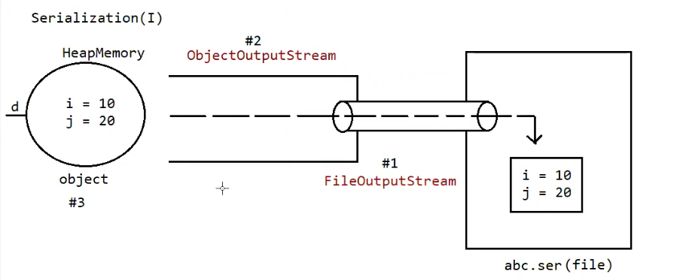

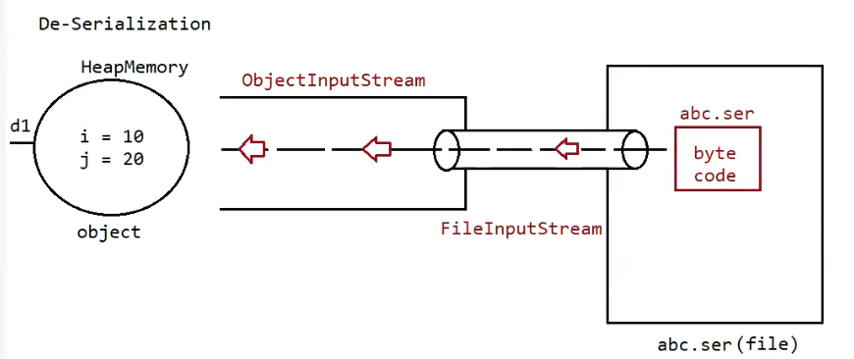

Eg: Serilization_Deserilization

Note: State of the object ( data present inside the object)

Note:

* We can perform serialization only on serializable objects
* An object is said to be serializable if and only if the corresponding class implements serializable interface
* Serializable interface present in io package does not contain any methods. It is marker interface. The required ability will be provided automatically by jvm.
* We can add any no of objects to the file, and we can read all the objects from the file but in which order we wrote objects in the same order only the objects will come back. That order is important.
* If we are trying to serialize a non-serializable object then we will get a runtime exception saying “NotSerializableException”.

Eg: Serialization_Deserialization_Multiple_Objects

// go through the code

Eg: Serialization_Deserialization_Multiple_Objects_Different_Order

// go through the code

Transient keyword:

* transient is the modifier applicable only for variable, but not for classes and methods
* while performing serialization if we don’t want to save the value of the particular variable to meet security constant such type of variable, then we should declare that variable with “transient” keyword
* at the time of serialization jvm ignores the original value of transient variable and save default value to the file.
* Transient means “not to serialize”.

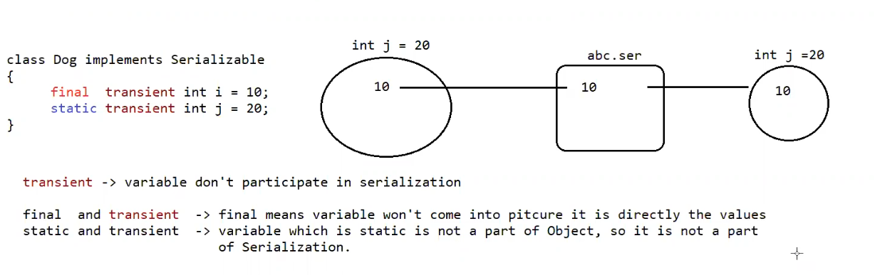

Eg: Serialization_Deserialization_Transient

// go through the code

Eg: Serialization_Deserialization_Final

// go through the code

Eg: Serialization_Deserialization_Static

// go through the code

Declaration output

1. int i=10;

int j=20;

output

10- 20

1. transient int i=10;

int j=20;

output :

0 ------- 20

transient int i=10;

transient static int j=20;

output:

0-------20

4.

transient final int i=10;

transient int j=20;

output

10 ------- 0

5.

transient final int i=10;

transient static int j=20;

output

10-----20

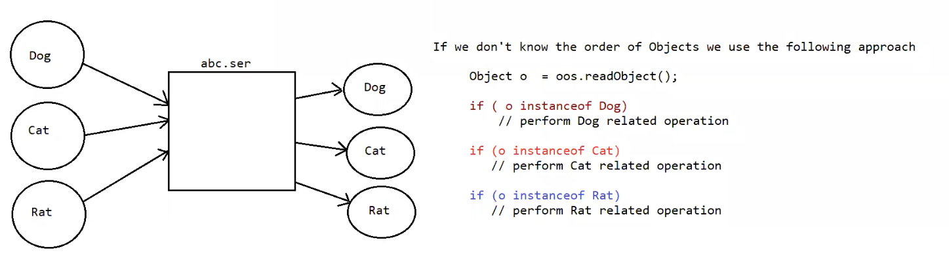

Eg: Serialization_Deserialization_Multiple_Objects_Different_Order__Using_InstanceOf

// go through the code

Object graph serialization:

1. Whenever we are serializing an object the set of all objects which are reachable from that object will be serialized automatically. This group of objects is nothing but object graph in serialization.
2. In object graph every graph should be serializable otherwise we will get runtime exception saying “NotSeriablizableException”.

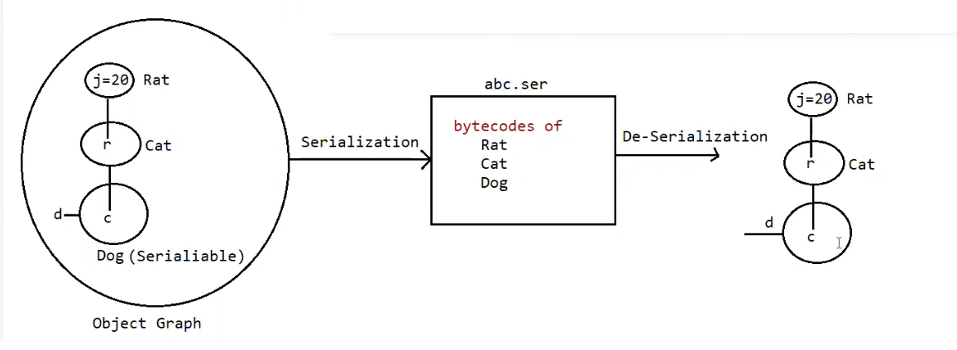

Eg: Object_Graph_Serialization

// go through the code

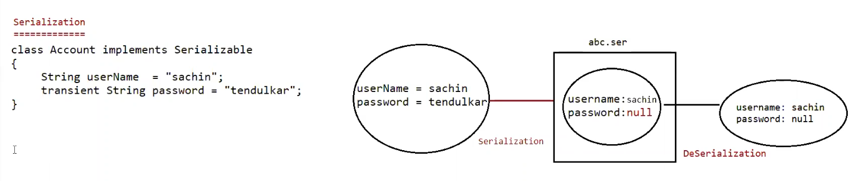

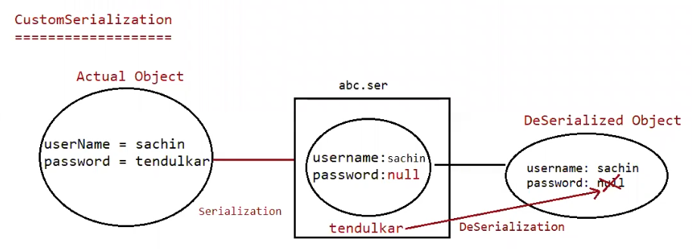

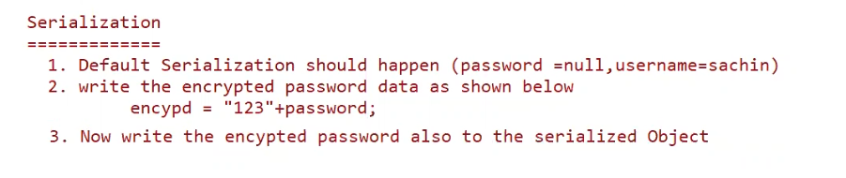

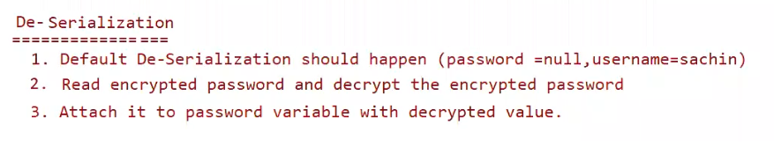

Custom-Serialization:

During default serialization there may be chance of lose of information due to transient keyword

We can implement custom serialization by using following to methods:

1. private void writeObject( ObjectOutputStream os ) throws Exception{

* this method will be executed automatically by jvm at the time of serialization.
* It is a callback method. Hence at the time of serialization if we want to perform any extra work we have to define that in this method only.

(prepare encrypted password and write the encrypted password separate to the file)

}

1. Private void readObject(ObjectInputStream is ) throws Exception{

This method will be executed automatically by jvm at the time of deserialization.

Hence at the time of deserialization if we want to perform any extra activity we have to define that in this method only.

(read encrypted password , perform decryption and assign decrypted password to the current object password variable )

Eg: Customized_Serialization_Transit

// go through the code

Eg: Customized_Serialization_Transit_Eg1

// go through the code

Eg: Customized_Serialization_Transit_Eg2

//go through the code